FOR IMMEDIATE RELEASE

CONTACT:
Jenni Walker – Walker PR Group – 980-339-8041-office/704-649-6571-cell
jenni@walkerprgroup.com

Platelet Drive in Memory of Isabella Santos – June 21-28
In partnership with the Isabella Santos Foundation and Community Blood Center of the Carolinas

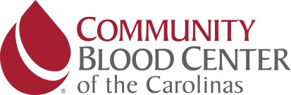

Attached and below is an event image courtesy of ISF and CBCC

CHARLOTTE, N.C. – MONTH/DAY, 2018 – One hundred platelet donations in memory of Isabella Santos. That’s the goal for the week-long platelet drive that the Isabella Santos Foundation is hosting with Community Blood Center of the Carolinas from Thursday, June 21-Thursday, June 28.

The platelet drive is being held on the sixth anniversary of Isabella Santos’ passing to celebrate her life and legacy. She passed away June 28, 2012, from a five-year battle with neuroblastoma, a rare type of pediatric cancer. During her treatment, she received several blood and platelet transfusions. According to CBCC, cancer patients are the No. 1 recipients of blood products. One local children’s hospital alone requires nearly 300 units of red blood cells and more than 100 units of platelets each month.

“Community Blood Center of the Carolinas has been near and dear to our hearts since Isabella received numerous blood and platelet transfusions to help her stay strong and fight neuroblastoma,” said Erin Santos, executive director and president of the Isabella Santos Foundation. “Hosting this platelet drive is an impactful way we can honor Isabella’s legacy and support local patients who need lifesaving platelets and blood products.”

Those interested can donate platelets at any of CBCC’s five donation centers in Charlotte (4447 South Blvd.); Concord (363 Church St. North); Gastonia (2524 E. Franklin Blvd.); Hickory (2217 Highway 70 SE); or Greensboro (616 Pasteur Drive). Those not able to donate platelets can give whole blood in honor of Isabella at any of CBCC’s donation centers. Appointments are required for platelet donations. To make a platelet donation appointment, email plateletdonor@cbcc.us or call 1-888-59BLOOD and use group code Isabella.

In addition, Jersey Mike’s will provide cookies to all presenting donors at CBCC’s Charlotte Donation Center on June 28 to thank the donors and celebrate Isabella with something sweet.

“ISF is the manifestation of Isabella’s legacy of community support and caring,” said Martin Grable, president and CEO of CBCC. “We deeply appreciate the relationship that has developed of the years. Partnering with such a determined and tremendously successful group of people dedicated to raising awareness of rare childhood cancer and what can be done about it makes our work at CBCC even more rewarding.

About Community Blood Center of the Carolinas
Community Blood Center of the Carolinas is the local nonprofit, community-based blood center and the primary blood supplier to the region’s hospitals. CBCC collects blood and blood products from volunteer donors in the community to return to the community at the lowest possible cost consistent with the highest possible standards. CBCC is a member of America’s Blood Centers, North America’s largest network of community-based, independent blood centers that provide more than 50 percent of the nation’s blood supply. For more information, visit http://www.cbcc.us/.
For more information on hosting a blood drive or donating blood in your area, visit www.cbcc.us or call 1-888-59BLOOD.

Follow Community Blood Center of the Carolinas on Facebook http://www.facebook.com/BloodCenter, on Instagram https://instagram.com/cbccarolinas/ and on Twitter www.twitter.com/CBCCarolinas.

About Isabella Santos Foundation
The Isabella Santos Foundation (ISF) is a 501(c)3 childhood cancer foundation dedicated to raising funds for research for neuroblastoma, other rare pediatric cancers, and charities that directly impact the lives of children with cancer. ISF was founded in honor of Isabella Santos from Charlotte, N.C. who lost her battle against neuroblastoma. ISF works to improve rare pediatric cancer treatment options in an effort to improve the survival rate of kids with cancer. For more information, visit www.isabellasantosfoundation.org or follow ISF on Facebook (www.facebook.com/IsabellaSantosFoundation), Instagram (www.instagram.com/theisfoundation) and Twitter (www.twitter.com/TheISFoundation).

# # #

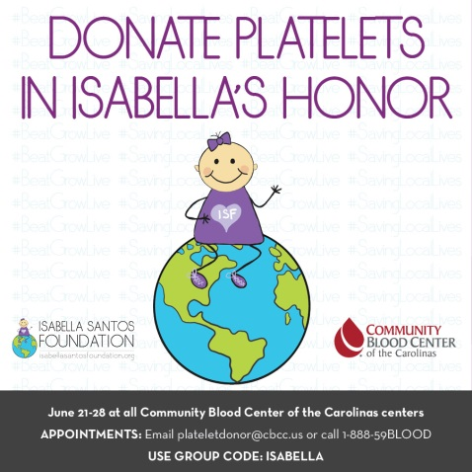

CONTACT:
Jenni Walker – Walker PR Group – 980-339-8041-office/704-649-6571-cell
jenni@walkerprgroup.com

